Assignment 1

Part A

I downloaded the simple.cpp from the website and paste it on the Xcode to run it

As the result, there is a red triangle

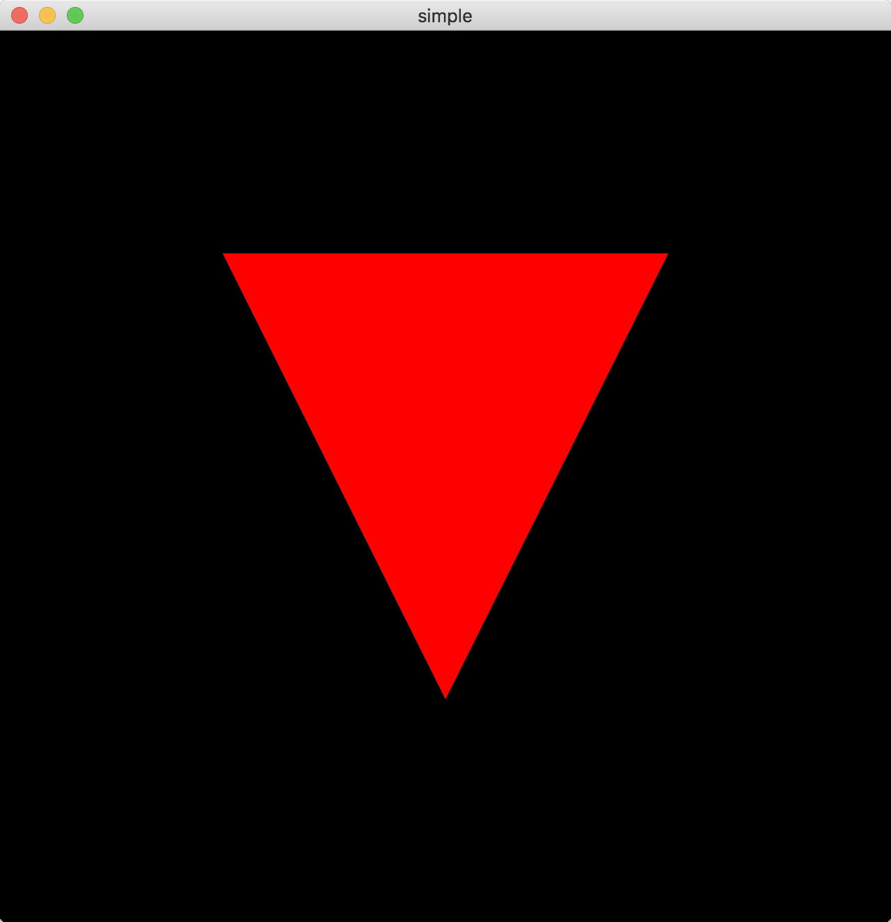

Part B

I downloaded the example1.cpp and run it on the Xcode, and get the following

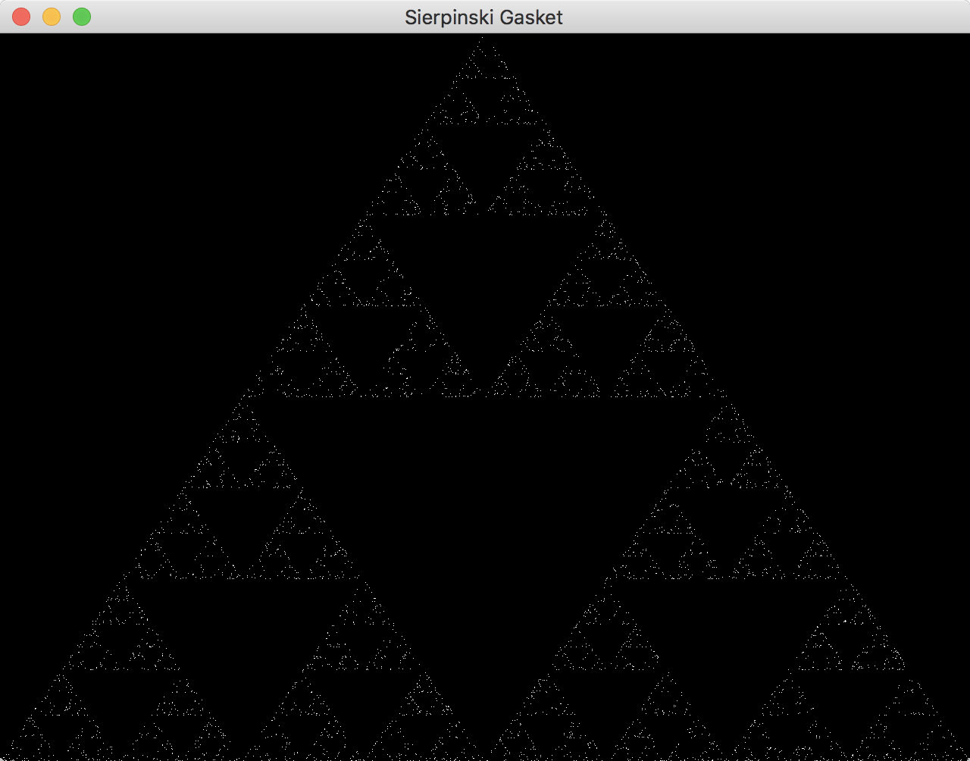

Part C:

I changed the triangle to a square and changed the color from red to white

